THEORY OF COMPUTATION AND COMPILER DESIGN PROJECT

(CSE 2002)

KARMEL A.

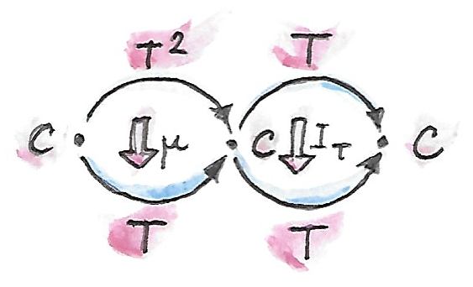

WINTER SEMESTER 2016-2017

|  |
| --- |
| ANALYSIS OF RESEARCH PAPER PERTANING TO CELLULAR AUTOMATA FOR PREDICTING FOREST FIRES |
|  |
|  |
|  |
|  |

KASHISH MIGLANI(15BCE1003)

**OSHO AGYEYA(15BCE1326)**

UTSAV RAI(15BCE1352)

RESEARCH PAPER 1

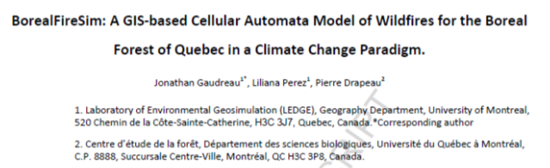

KEYWORDS:

Wildfires; Complexity; Modelling; GIS; Climate Change; Cellular Automata

HIGHLIGHTS:

* ➢ Climate Change will likely alter wildfire patterns in the boreal forest of Quebec
* ➢ BorealFireSim can model those wildfire patterns
* ➢ Forecasts show increases in fire likelihood
* ➢ Important changes in fire patterns for the northeastern part of the boreal forest
* ➢ Fire likelihood and vegetation productivity forecasts are overlapping

INTRODUCTION:

In contrast, BorealFireSim works at a provincial scale, and focuses on a long term spatio-temporal changes in wildfire patterns in the boreal forest, dealing with many fire events in space and

in time. Given that wildfire ignition can be caused by diverse interacting conditions, such as climate, elevation, dryness, tree species, weather, and presence of wet areas, the complex dynamics between these conditions give rise to spatial patterns of burned areas, emerging from local

interactions to global scale patterns through time.

FORMULA:

Cellular automata are models comprising a grid of cells where each one has a finite number of states. The state of a cellis influenced by the neighboring cells via transition rules. These transitions rules are applied to each cell for a certain number of time steps. In CA models, the state of a cell can be summarized with the following equation:

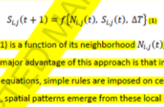

where the state (S) of a cell i,j at a time (t+1) is a function of its neighborhood , and its state at the previous time within a discrete time step . The major advantage of this approach is that instead of running simulations on the whole system with complex mathematical equations, simple rules are imposed on cells that can only interact with their neighbors. During and after the simulation, spatial patterns emerge from these local interactions between cells.

**Spotting effect** is a phenomenon where burning material is transported by wind to areas

not adjacent to the fire front, sometimes causing the ignition of a new, independent, fire event. Even though spotting could be important for fire front evolution models, this phenomenon is not relevant on a provincial scale, where the spatial resolution doesn’t allow these short range (100 meters approximately) dynamics.

FLOW CHART:



AREA:

The extent covered by BorealFireSim for this research is 45.375 N to 59.491 N to 79.757 W to 57.112W and its spatial resolution is 4.48x4.48 km or 20kmsq.

PARAMATERS USED:

The **FWI** is an index of the fire severity and was originally conceived as a way to represent fire intensity, as defined by Byram (1959) in the equation:

**I = HWR**

where the energy output rate per unit length of fire front I is the combination of the heat of combustion H, the weight of fuel consumed per unit area W and the rate of advance R. Components of FWI are:



The **representative concentration pathways (RCPs)** is defined as a cumulative measure of human emissions of greenhouse gases from all sources expressed in Watts by square meter.

Stands with age over 80 years are considered as mature forest and they are more prone to fire because its multiples layers of tree heights serving as a fire ladder. Dominant species are used to categorize fire-prone conifers, such as black spruces and jack pines, while giving less chance of burning to hardwoods such as birch or maple

MODEL:

Non-flammable cells are cells that are turned off in the model and they consist of roads, rivers and lakes and cells that are not part of the study area or have *nodata* values; to summarize, these cells are non-suitable to spread the fire and therefore can never change state. Cells with a state value of 1 are cells with unburned vegetation, without discrimination to the dominant species, the density or the percentage of wet areas; hence they all have a chance of burning. These cells can either stay unburned to be ignited by lightning or by fire spreading. When a cell is burned, its state changes to 2 for the current time step and will be set to 3 at the end of the same time step. Since the temporal resolution of the model is a year, a cell that is ignited will pass from state 1 to state 2 to state 3 in the same iteration.

Once a cell passes to state 3, it can either stay burned or start regrowing. Finally, cells with state 4 will eventually change to state 1 as they mature if they are not burned once again. Every iteration, each cell evaluates its eight neighbors and the algorithms determine if the state of the cell should change. The Moore neighborhood was selected since it is more representative of real processes of fire propagation.



Cell states and possible transitions:

Non-flammable 0   
[0] ==> [0]

Vegetation (fuel) 1  
[1] ==> [1]

[1] ==> [2]

Burning 2

[2] ==> [3]

Burned forest 3

[3] ==> [3]

[3] ==> [4]

In regrowth 4

[4] ==> [1]

These processes are executed by five procedures called: 1) ignition, 2) spreading, 3) fading, 4) regrowth and 5) maturation, and are repeated on a yearly basis.

FIRE SPREAD ALGORITHM:

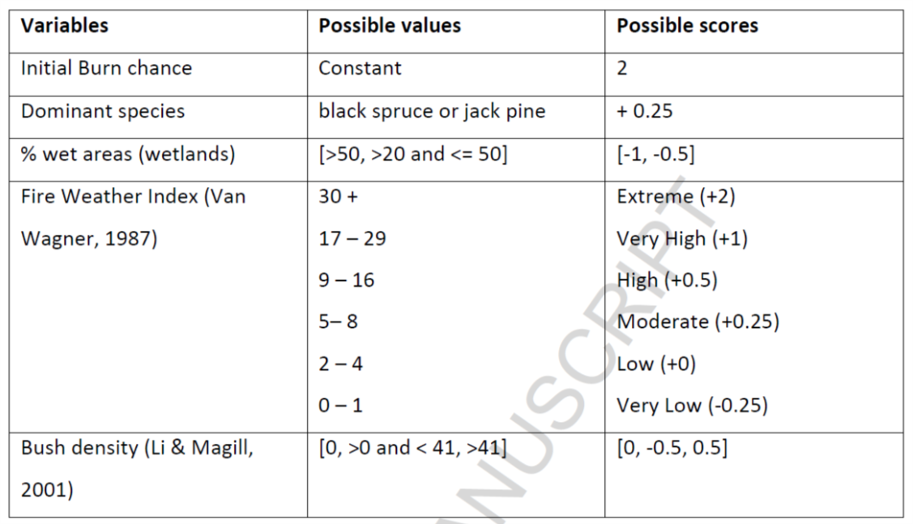

After all the scores are defined for a cell, a burning chance (BC) is calculated for every cell, by dividing the sum of its scores by the maximum sum reached by a cell. This gives every cell a BC from 0 to 1 representing the chance of fire spreading over it, if one of its neighbors is previously ignited. The calculation of burning chance can be summarized with the following equation:

**BC (i,j) = (2+DS(i,j)+ D(i,j) +FWI(I,j)+W(i,j)/ MbC**

where BC is calculated with a minimal chance of 1 for every cell, the dominant species score (DS), density score (D), fire weather index (FWI) and wet areas score (W) divided by the maximal BC of all cells (MbC).

REGROWTH ALGORITHM:

A regrowth algorithm is used to determine the timing of post fire regrowth. This algorithm uses three values for the regrowth decision: 1) the presence of burning neighbors, 2) the presence of living neighbors and 3) the species found on the cell prior to ignition. For instance, if jack pines and black spruces were present before the fire, regrowth will be accelerated because of their serotinous and semi-serotinous cones that sprout when subject to intense heat, as fire. Regrowth chance (RC) is calculated with the following equation:

**RC(i,j) = (FN(i,j) + LN(i,j) + DS(i,j) ) / MrC**

MODEL OUTPUTS:

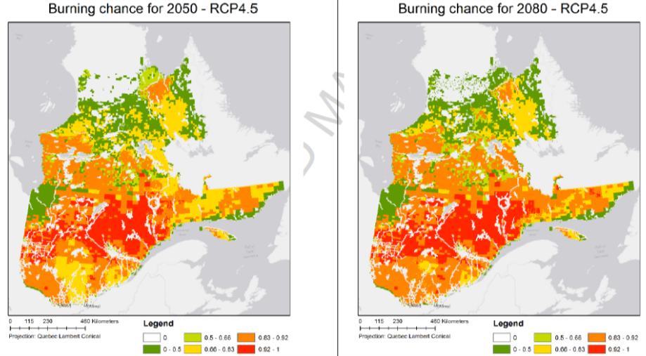

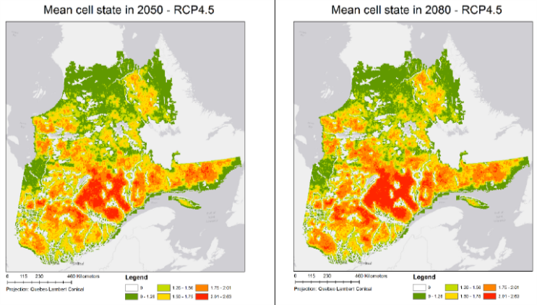

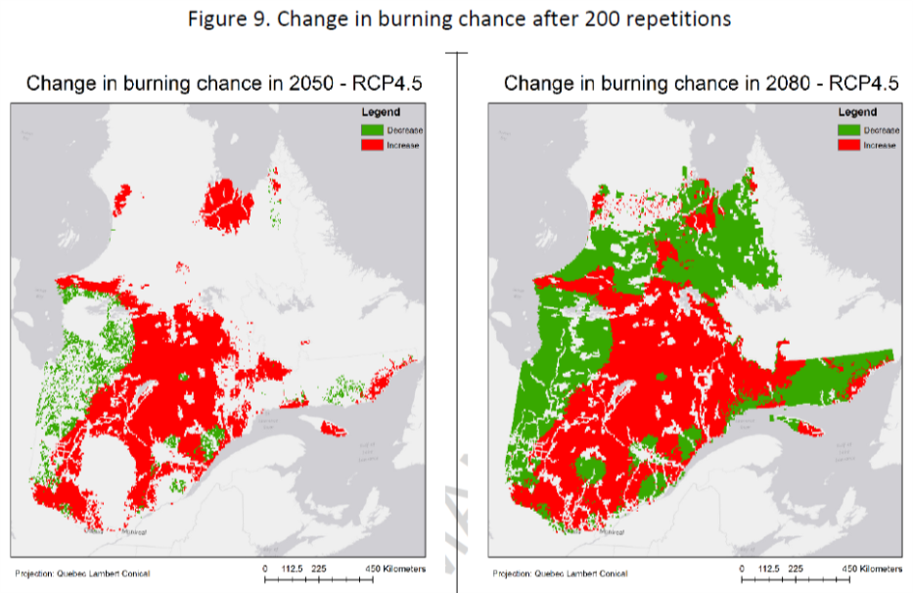

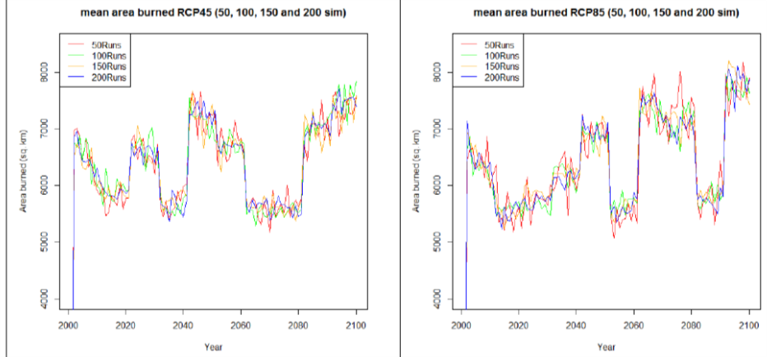

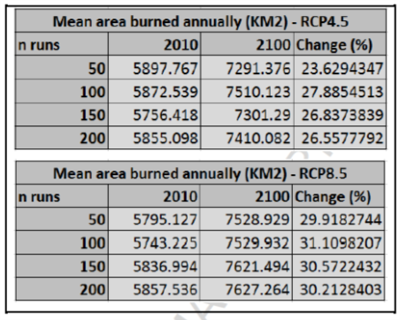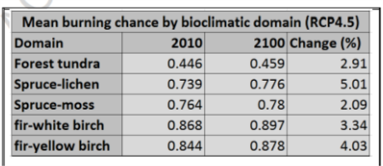

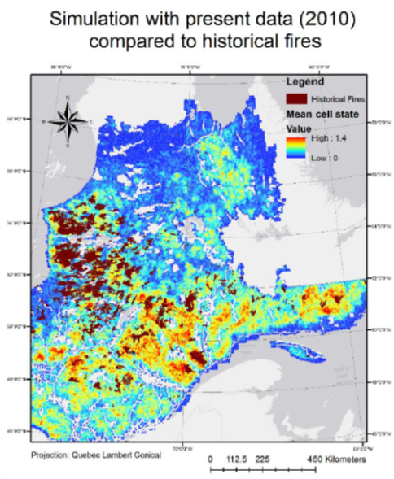

Conclusion:

The results show that, in all cases, the mean area of burned forest will likely increase with both a low emission of a high emission climate scenario, increasing by 30.2% by the end of the century with a Business As Usual (BAU) scenario. Knowing this, conservation agencies can plan their future policies by integrating forecasts from BorealFireSim and by focusing on protecting areas with higher fire risk and higher greenness, as they will be key areas for fire specialist species.

REFERENCES:

Alexandridis, a., Vakalis, D., Siettos, C.I., Bafas, G.V., 2008. A cellular automata model for forestfire spread prediction: The case of the wildfire that swept through Spetses Island in 1990.

Appl. Math. Comput. 204, 191–201.

Alexandridis, A., Russo, L., Vakalis, D., Bafas, G.V., Siettos, C.I. 2011. Wildland fire spread

modelling using cellular automata: Evolution in large-scale spatially heterogeneous

environments under fire suppression tactics. International Journal of Wildland Fire 20 (5):

633-647.

Authors, D., Alexander, L., Allen, S., 2013. Working Group I Contribution to the IPCC Fifth

Assessment Report Climate Change 2013: The Physical Science Basis Summary for

Policymakers.

Batty, M. and P. Torrens. (2001). Modeling Complexity: The limits to Prediction. CyberGeo:

European Journal of Geography: Dossiers, 12th European Colloquium on Quantitative and

Theoretical Geography, France, September 7-11 2001.

Barrett, K. E.S. Kasischke, A.D.McGuire, M.R. Turetsky, E.S. Kane. (2010) Modeling fire severity in

black spruce stands in the Alaskan boreal forest using spectral and non-spectral geospatial

data. Remote Sensing of Environment 114: 1494-1503

Bergeron, Y. S. Gauthier, V. Kafka, P. Lefort. D. Lesieur. (2006). Natural fire frequency for the

eastern Canadian boreal forest: consequences for sustainable forestry. Canadian Journal of

Forestry 31:384-391

Bone, C., Dragicevic, S., Roberts, A., 2006. A fuzzy-constrained cellular automata model of forest

insect infestations. Ecol. Modell. 192, 107–125.

Bone, C., White, J., Wulder, M., Robertson, C., Nelson, T., 2013. Impact of Forest Fragmentation

on Patterns of Mountain Pine Beetle-Caused Tree Mortality. Forests 4, 279–295.

Bonnot, T. W., Millspaugh, J. J., & Rumble, M. a. (2009). Multi-scale nest-site selection by blackbacked

woodpeckers in outbreaks of mountain pine beetles. Forest Ecology and

Management, 259, 220–228. doi:10.1016/j.foreco.2009.10.021

Breiman, L. (2001). Random Forests. Journal of Machine Learning 45:1 pp 5-32.

British Columbia Forest Service Wildfire Management Branch. (2014) Fire Resistant Trees.

http://bcwildfire.ca/Prevention/property/Landscape/fireresistantplants.htm. Last access

on 27/02/2015

Byram, G.M. 1959. Combustion of forest fuels. Chapter 3 in K.P. Davis, ed. Forest Fire: Control

and Use, McGraw-Hill, New York

Canadian Forest Service (2001). Canada's Forest Inventory (CanFI) 2001 for the boreal ecoregion

- percent forested, Quebec.

<http://databasin.org/datasets/a852f638bb424439a308b1aa0e8f1d6b>

Dale, V. H., Joyce, L. A., Mcnulty, S., Neilson, R. P., Di, S., Ridge, O., & Box, P. O. (2008). The

interplay between climate change , forests , and. BioScience, 201–204.

Dale, V. H., Joyce, L. A., Mcnulty, S., Ronald, P., & Matthew, P. (2001). Climate Change and

Forest Disturbances. BioScience, 51(9), 723–734

.

De Groot, W. (2012). CanFIRE. Natural Resources Canada. Canadian Forest Service. Great Lakes

Forestry Centre. Sault Ste. Marie, Ontario. Frontline Express 62. 2p.

Drever, C. R., C. Messier, Y. Bergeron, F. Doyon. (2006) Fire and canopy species composition in

the Great Lakes-St. Lawrence forest of Témiscamingue, Québec. Forest Ecology and

Management 231: 27-37.

RESEARCH PAPER II

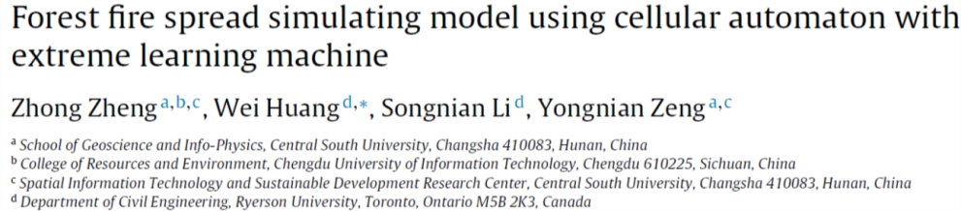

KEYWORDS:

Cellular automaton, Machine learning, Forest fire, Simulation

INTRODUCTION:

In this modelling approach, the local evolution rules of fire spreading are created by ELM using local historic training data, which ensures the building of a simple CA modelling approach that can be easily applied without considering the complicated theory of traditional modelling approaches and several physical parameters. The paper is structured as follows.

The background of CA modelling approach is introduced in Section1.

Section 2 reviews the recent efforts in the field of data-driven fire spread simulation.

Section 3 presents the details of the proposed cellular automaton modelling approach, followed by the study area and data.

Section 5 presents results and discussion.

Finally, Section 6 provides the conclusion of this study and the work needed to be done further.

METHODOLOGY:

Therefore, the entire operations are divided into three sections: (a) Data collection and pre-processing,

(b) Modelling approach building, and (c) Model validation. This section mainly introduces the modelling approach building and model validation.

Cell and its state definitions :

For this work, the square-lattice was selected and the 2D-regular square grids were used as cells of the CA frame-work, since this can simplify the calculations and thus considerably reduce computational complexity. Each square-lattice cell at different discrete time steps can be characterized by the following four possible states :

State 1: the cell containing no fuel cannot be burned.

State 2: the cell containing fuel has not been ignited.

State 3: the cell containing fuel is burning.

State 4: the cell containing fuel has already been burned.





TRANSITION RULES:

Rule 1. IF the state of cell (i, j) at discrete time step (t)is unburned; THEN the state of cell (i, j) is unburned at the next discrete time step (t + 1). This rule means that a cell containing no fuel will not be ignited and thus its state remains as unburned.

Rule 2. IF the state of cell (i, j) at discrete time step (t) is burning; THEN the state of cell (i, j) is burned at the next discrete time step (t + 1). This rule indicates that the state of a burning cell will be updated to be the burned state at the next discrete time step.

Rule 3. IF the state of cell (i, j) at discrete time step (t) is burned; THEN the state of cell (i, j) is burned at the next discrete time step (t + 1). This rule implies that the cells that have already been burned cannot be reignited again and thus its state remains as burned.

Rule 4. IF the state of cell (i, j) at discrete time step (t) is not-ignited and there is one or more than one burning cell in its Moore neighboring cells (i ± 1, j ± 1); THEN the state of cell (i, j) with a higher transition probability (i.e., Pti,j that measures the likelihood of cell’s state transition) will be burning at the next discrete time step (t + 1).This rule implies that a cell containing combustible fuel will be burning, if one or more than one burning cell in its Moore neighboring cells and its **state transition probability (i.e., Pti,j)** is higher than a random probability threshold (i.e., (theta)t), as shown in Eq. (1):

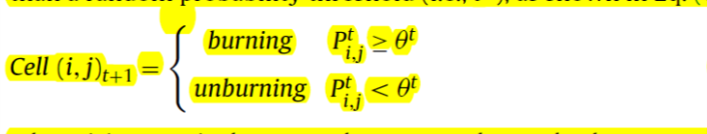

where i, j respectively means the row number and column number of Cell (i, j).

The transition function can be split into two types of components: the internal transformation and the local interaction. Similarly, for each cell (i, j) of this study, its state transition probability can also be expressed as a function of two sub-components, as shown in Eq. (2):

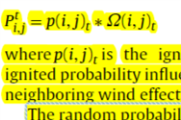

where **p(i, j)t is the igniting probability** which measures cell’s ignited probability influenced by its own factors and (i, j)t means neighboring wind effects caused by cell’s neighborhoods.

The random probability threshold in Eq. (1) is calculated by following formula:

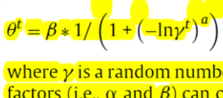

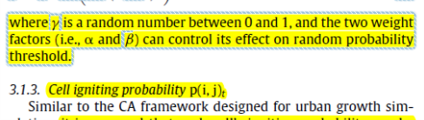

For each cell of forest fire, the values of its driving force data are considered as the inputs (i.e., xi) of ELM model and its igniting probability is considered as the output (i.e., ti) of ELM model. To be specific, given N distinct samples (xi, ti), the goal of ELM estimation is to find a quantitative relationship between [x1, x2, . . ., xi]N and [t1, t2, . . ., ti]N. For the output of an ELM model with M nodes in the hidden layer, it can be represented by Eq. (4):

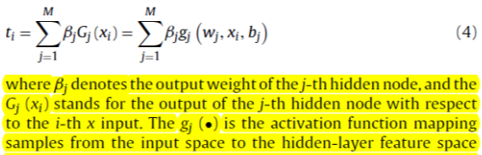

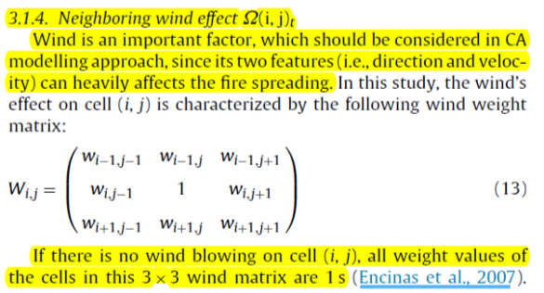

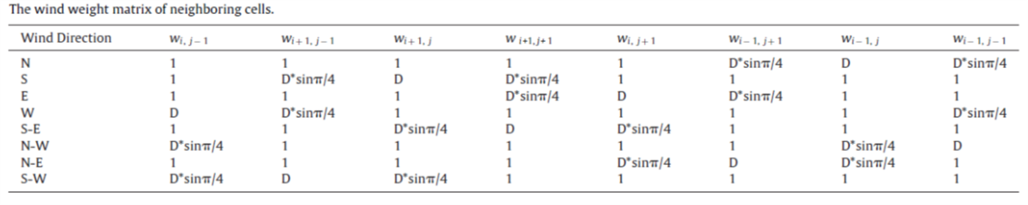

Otherwise, their values would be assigned based on table above.

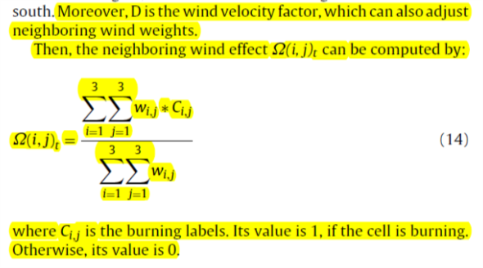

Spreading time step Δt.: It can be calculated using the centroid distances between two adjacent cells (i.e., L) and the Rate of Spread (ROS)

Δt = L/ROS

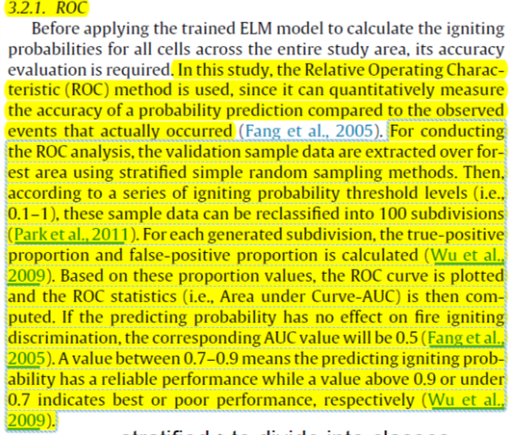

Data and pre-processing: In this study, the confusion matrix, i.e. a standard accuracy assessment for remote sensing image classifications is applied. For details, as far as the final burned area is predicted, its boundary is overlaid with fire’s real burned perimeter. The confusion matrix is calculated and the five quantitative measurements (i.e., burned actual-burned predicted (%), burned actual-not burned predicted (%), not burned actual-burned predicted (%), burned actual area (km2), and burned predicted area(km2)) are recorded.



For each distinct sample, its driving force values were considered as the input (i.e., xi) of ELM model, and its igniting probability (i.e., ti) was considered as the output of ELM model. If the distinct sample was extracted from unburned area, its igniting probability was assigned as 0. Otherwise, its igniting probability (i.e., ti) was assigned as 1 if it was extracted from burned area. In this study about 14000 distinct samples with input values and igniting probabilities were randomly extracted from the Coal Seam Fire: 7000over unburned areas and 7000 over burned areas. These distinct samples were then used to train the ELM model. After that, using the driving force values of validation samples for each fire as the input of trained ELM, we calculated each sample’s igniting probability and applied it to evaluate the ELM’s performance. Specifically for each fire in this study, the total number of validation samples was about 6000, including 3000 from burned areas and 3000 from unburned areas.

RESULTS AND DISCUSSIONS:



Additionally, when we used this trained ELM to predict the igniting probability of coming fires broke out in the neighborhood, the AUC values for other forest fires (i.e., Spring Creek Fire, Big Elk Fire Mustang Fire and Bear Fire) were 0.69, 0.74, 0.70, and 0.72, respectively. From this result (i.e., almost all AUCs of these fires are larger than 0.70), we can say that the trained ELM also had a credible precision when it was used to predict the igniting probability of future fires broke out in the neighborhood.

Wind sensitivity analysis:

The wind is a critical factor affecting fire spreading patterns. This study investigated the effects of the wind parameters (i.e., direction and velocity). Fire spreads along the direction of wind.



Accuracy evaluation of simulation results for each fire:



CONCLUSION:

Results indicate that the ELM performed well in predicting each cell’s igniting probability, the proposed method can effectively describe impact of wind velocity on fire spreading pattern, and the simulation accuracy (i.e., the Burned Actual-Burned Predicted is between 58.45 and 82.08%) is reliable. We can conclude that the proposed modelling approach is easily applied and effectively simulated the fire behavior.

REFERENCES:

Abdalhaq, B., Cortés, A., Margalef, T., Luque, E., 2005. Enhancing wildland fireprediction on cluster systems applying evolutionary optimization techniques.Fut. Gener. Comput. Syst. 21, 61–67.

Albinet, G., Searby, G., Stauffer, D., 1986. Fire propagation in a 2-D randommedium. J. Phys. 47, 1–7.

Alexandridis, A., Vakalis, D., Siettos, C.I., Bafas, G.V., 2008. A cellular automatamodel for forest fire spread prediction: the case of the wildfire that sweptthrough Spetses Island in 1990. Appl. Math. Comput. 204, 191–201.

Alexandridis, A., Russo, L., Vakalis, D., Bafas, G., Siettos, C., 2011. Wildland firespread modelling using cellular automata: evolution in large-scale spatiallyheterogeneous environments under fire suppression tactics. Int. J. WildlandFire 20, 633–647.

Bianchini, G., Denham, M., Cortés, A., Margalef, T., Luque, E., 2010. Wildland firegrowth prediction method based on multiple overlapping solution. J. Comput.Sci. 1, 229–237.

Brun, C., Margalef, T., Cortés, A., Sikora, A., 2014. Enhancing multi-model forest firespread prediction by exploiting multi-core parallelism. J. Supercomput. 70,721–732.

Cannon, S.H., Gartner, J.E., Holland-Sears, A., Thurston, B.M., Gleason, J.A., 2003.Debris-flow response of basins burned by the 2002 Coal Seam and MissionaryRidge fires, Colorado. In: Boyer, D.D., Santi, P.M., Rogers, W.P. (Eds.),Engineering Geology in Colorado-contributions, Trends, and Case Histories.AEG Special Publication 15. Colorado Geological Survey Special Publication.

Chang, Y., Zhu, Z., Feng, Y., Li, Y., Bu, R., Hu, Y., 2016. The spatial variation in forestburn severity in Heilongjiang Province, China. Nat. Hazards 81, 981–1001.

Clarke, K.C., Gaydos, L.J., 1998. Loose-coupling a cellular automaton model andGIS:long-term urban growth prediction for San Francisco andWashington/Baltimore. Int. J. Geogr. Inf. Sci. 12, 699–714.

Collin, A., Bernardin, D., Sero-Guillaume, O., 2011. A physical-based cellularautomaton model for forest-fire propagation. Combust. Sci. Technol. 183,347–369.

Denham, M., Wendt, K., Bianchini, G., Cortés, A., Margalef, T., 2012. Dynamicdata-driven genetic algorithm for forest fire spread prediction. J. Comput. Sci.3, 398–404.

Encinas, A.H.a., Encinas, L.H.a., White, S.H., del Rey, A.M.i., S’anchez, G.R.i., 2007.Simulation of forest fire fronts using cellular automata. Adv. Eng. Softw. 38,372–378.

FAMWEB, 2015. Fire & Weather Data, 14 December, 2015 <http://fam.nwcg.gov/fam-web/weatherfirecd/>.

Fang, S., Gertner, G.Z., Sun, Z., Anderson, A.A., 2005. The impact of interactions inspatial simulation of the dynamics of urban sprawl. Landsc. Urban Plan. 73,294–306.

Ghisu, T., Arca, B., Pellizzaro, G., Duce, P., 2015. An optimal Cellular Automataalgorithm for simulating wildfire spread. Environ. Modell. Softw. 71, 1–14.

Gonc¸ alves, P., Diogo, P., 1994. Geographic information systems and cellularautomata: A new approach to forest fire simulation. In: Proceedings of TheEuropean Conference on Geographical Information Systems (EGIS 94), Paris,France, pp. 702–712.

Hernández Encinas, A., Hernández Encinas, L., Hoya White, S., Martín del Rey, A.,Rodríguez Sanchez, G., 2007. Simulation of forest fire fronts using cellularautomata. Adv. Eng. Softw. 38, 372–378.

Hogeweg, P., 1988. Cellular automata as a paradigm for ecological modeling. Appl.Math. Comput. 27, 81–100.

Huang, G., Zhou, H., Ding, X., Zhang, R., 2012. Extreme learning machine forregression and multiclass classification. IEEE Trans. Syst. Man Cybern. Part B:Cybern. 42, 513–529.

Huang, G., 2015. What are extreme learning machines?: Filling the gap betweenFrank Rosenblatt’s dream and John von Neumann’s puzzle. Cognit. Comput. 7,263–278.

Jackson, S.T., Betancourt, J.L., Lyford, M.E., Gray, S.T., Rylander, K.A., 2005. A40,000-year woodrat-midden record of vegetational and biogeographicaldynamics in north-eastern Utah, USA. J. Biogeogr. 32, 1085–1106.

Karafyllidis, I., Thanailakis, A., 1997. A model for predicting forest fire spreadingusing cellular automata. Ecol. Model. 99, 87–97.

LANDFIRE, 2015. Vegetation Products, 10 December, 2015 <http://www.landfire.gov/>.

Lan, Y., Soh, Y.C., Huang, G.-B., 2010. Two-stage extreme learning machine forregression. Neurocomputing 73, 3028–3038.

Li, X., Liu, X., 2006. An extended cellular automaton using case-based reasoning forsimulating urban development in a large complex region. Int. J. Geogr. Inf. Sci.20, 1109–1136